**How to become a Better Programmer - Code Refactoring?**

**Ways:**

1. Don’t repeat yourself.
2. We enjoy typing.





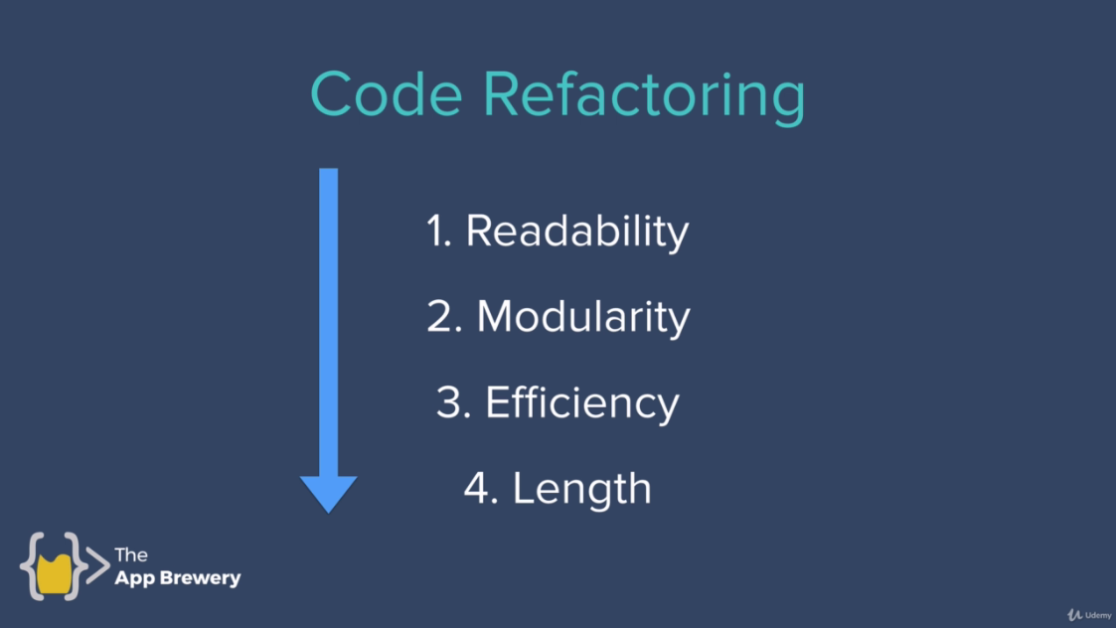

**Code Refactoring:**

* **Readability:** The code should be easy to read.
* **Modularity:** How easier to use the code.
* **Efficiency:** Code should be efficient.
* **Length:** Code Length must be as minimum as possible with same functionality as required.

Practice Questions:

<https://codegolf.stackexchange.com>